EAGE

EUROPEAN
ASSOCIATION OF
GEOSCIENTISTS&
ENGINEERS

Changchun Yin
No.938ofXiminzhu Str.Chaoyang，130026
China

30March2017

DearMrYin，

Itiswith greatpleasurethat weinviteyoutoattend

The79thEAGE Conference&Exhibition，Paris2017whichwi1lbeheldinParis，France, from12June2017to15June2017.

Yourregistrationandinvitationcoversthefollowingperson(s):
Delegate: Changchun Yin
Born 15May1965

VENUE:
ParisExpoPortedeVersailles
1PlacedelaPortedeVersailles，
75015Paris
EAGE Conference bv

POBox59
3990DBHouten
TheNetherlands

www.eage.org

Telephone
+31889955055
Telefax
+31 306343534
E-mail:
eage@eage.org

Forthesakeofgood order，weadviseyouthatinsupplyingthisletter，neithertheAssociationnorEAGEConferences
B.V. willaccept anyobligationtopayanyexpensesincurredbyyou

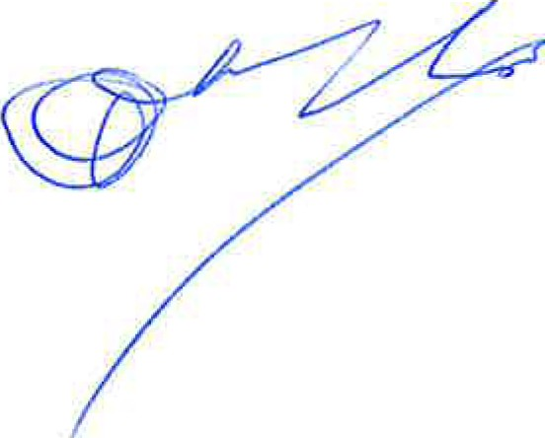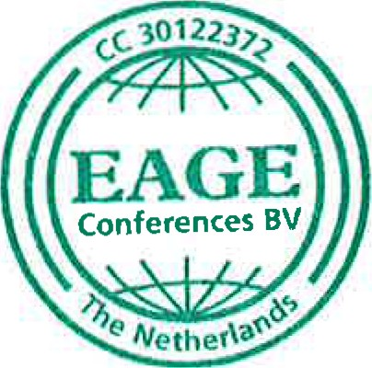YoursSincerely，

M.VanLoon
EAGEExecutiveDirector

ABN-AMRO
TheNetherlands
Account IBANnumber:
NL09ABNA0446255300
BICSwiftcode:
ABNANL2A

PARIS2017
12-15June2017 Paris ExpoPortedeVersailles
FranceVATnumber:
FR57433658788

ChamberofCommerceUtrecht30122372

